AI Agent Chatbot Creation Platform

This document explains how to explore the AI Agent Orchestration Platform, create a new travel itinerary agent, interact with the agent for trip planning, and share the generated itinerary through WhatsApp using the integrated Twilio service.

Step 1: Explore the Repository and Open the Project
Begin by reviewing the AI Agent Orchestration Platform codebase to understand its architecture, functionality, and implementation.

Review the Repository
Open the GitHub repository for the AI Agent Orchestration Platform and review the project documentation.
Go through the following sections in the README:
- Overview
- Key Features
- Run the Pre-requisite commands
This provides an understanding of the platform’s objectives, system design, and supported capabilities.

Open the Project in Visual Studio Code (VS Code)
Open the project folder in Visual Studio Code (VS Code).
Review the following core files to understand the application flow and backend logic:
- frontend.py — Handles the Streamlit user interface and user interactions
- agent_store.py — Manages agent creation, storage, routing, and execution
- Other .py files — Explore supporting modules for integrations, services, and platform functionality

Launch the Application
Open the integrated terminal in VS Code (or use your system terminal) and start the application using:
streamlit run frontend.py
This launches the AI Agent Orchestration Platform locally, allowing you to create agents, chat with them, manage conversations, and share responses via WhatsApp.

High Level Architecture Diagram

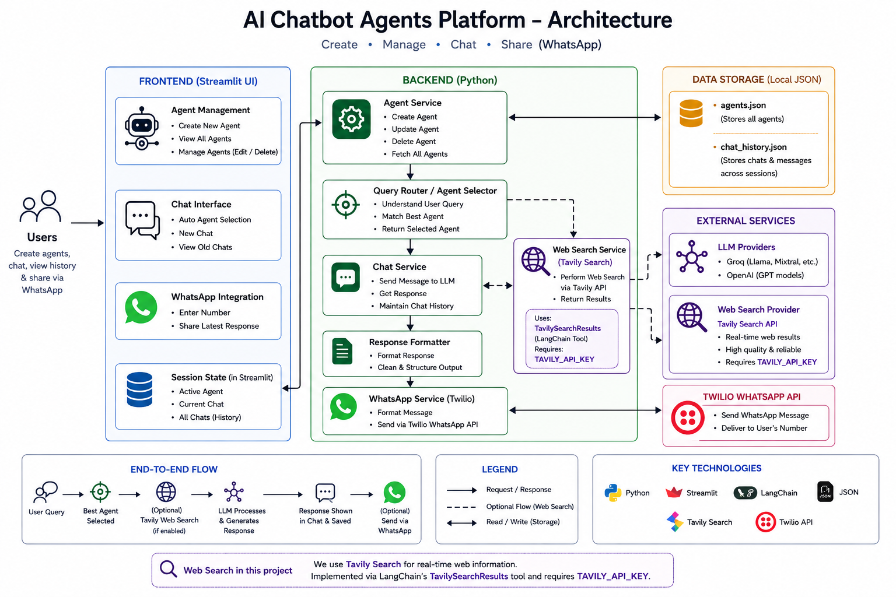

Process Overview
The AI Chatbot Agents Platform allows users to create, manage, and interact with custom AI agents through a user-friendly interface. Users can configure agents with custom prompts, models, providers, and capabilities, then chat with them in an interactive environment.
The application supports:
- Custom AI agent creation
- Agent management (view, edit, delete)
- Multi-chat support (new chat & old chat history)
- Smart agent routing
- WhatsApp integration for sharing responses
- Persistent chat recovery on reload

1. Create New Agent
Users can create specialized AI agents from the main interface.

Inputs Required While Creating an Agent

1. Agent Name
A unique name to identify the AI agent.
Example:
- Travel Planner
- Resume Reviewer
- Transport Assistant

2. System Prompt
Defines the role, behavior, rules, and expertise of the agent.
This acts as the agent’s instruction set and controls:
- Scope of responses
- Domain specialization
- Restrictions
- Output formatting
- Decision-making logic
Example:
A travel itinerary assistant can be instructed to only answer trip-planning related queries.

3. Model Provider
Users can choose the LLM provider:
- Groq
- OpenAI

4. Model Selection
Based on provider selection, users can choose a model.
Example models:
Groq:
- llama-3.3-70b-versatile
- mixtral-8x7b-32768
OpenAI:
- gpt-4o-mini

5. Web Search Toggle
Users can enable or disable web search capability.
When enabled:
- Agent can use web-supported responses.
When disabled:
- Agent responds only using model knowledge.

6. Test Query (Optional)
Users can test an agent before saving by entering a sample query.
This helps validate:
- Prompt quality
- Agent behavior
- Response formatting

7. Save Agent
Clicking Save Agent stores the configuration for future use.
Saved agent details include:
- Agent name
- Model
- Provider
- System prompt
- Search preference

2. View All Agents
Users can inspect all saved agents.
Feature access:
📂 View All Agents
This section displays:
- Agent name
- Selected model
- Provider
- Web search configuration
- System prompt
Purpose:
- Quickly inspect agent configurations
- Verify prompt setup
- Review capabilities before chatting

3. Manage Agents
Users can manage previously created agents.
Feature access:
⚙️ Manage Agents
Supported actions:

Edit Agent
Users can modify:
- Model name
- Provider
- System prompt
Use case:
- Improve prompt behavior
- Change model performance
- Update capabilities
After editing:
Click Update to save changes.

Delete Agent
Users can permanently remove agents.
Process:
- Select agent
- Click Delete
Use case:
- Remove unused agents
- Clean outdated configurations

4. Agent Chat Experience
Users interact with agents from the chat panel.
Feature:
💬 Chat With Agent

Smart Agent Routing
When a message is entered:
- System analyzes the query
- Finds the most suitable agent
- Routes request automatically
Example:
Query:
“Plan a Goa itinerary”
→ Routed to travel agent.
If no suitable agent exists:
User receives:
“No related agent found for your query.”
This prevents hallucinated or irrelevant responses.

5. New Chat Feature
Feature:
➕ New Chat
Allows users to start a fresh conversation.
Behavior:
- Creates a new chat session
- Clears prior conversation context
- Preserves previous chats
Example:
chat_1 → old travel discussion
chat_2 → new resume discussion
Purpose:
- Context isolation
- Multiple conversations simultaneously

6. Old Chats / Chat History
Feature:
📂 View Old Chats
Displays recent conversations.
Capabilities:
- Shows latest chats
- Switch between chats
- Resume previous discussion
Current behavior:
- Last 5 chats displayed
- Most recent chat shown first
- Active chat highlighted
- Latest chat automatically opens after page reload
Benefits:
- Persistent conversation history
- Easy chat switching
- Better user experience

7. Persistent Chat Recovery
Chats are automatically stored and restored.
Behavior:
- Page reload does not lose history
- Previous chats remain accessible
- Latest chat opens automatically after refresh
Benefits:
- No conversation loss
- Session continuity

8. WhatsApp Integration
Feature:
📲 Share Discussion
Allows users to share AI-generated responses directly to WhatsApp.
Workflow:
- Enter mobile number
- Click Send via WhatsApp
- Latest assistant response is shared
Supported formats:
- 10-digit Indian number
Example:
9876543210
- Country code format
Example:
+919876543210
Use cases:
- Share travel itineraries
- Share recommendations
- Save AI-generated plans
- Send summaries instantly
Example flow:
User creates itinerary → Agent generates plan → Send to WhatsApp
Benefits:
- Easy portability
- Mobile access
- Instant sharing

9. High-Level User Flow
Create Agent
→ Save Agent
→ Chat With Agent
→ Start New Chat (optional)
→ View Old Chats (optional)
→ Send Results via WhatsApp

Conclusion
The platform enables users to create domain-specific AI agents, manage them dynamically, interact through persistent multi-chat conversations, and share outputs seamlessly through WhatsApp integration.

